Laser operation instruction

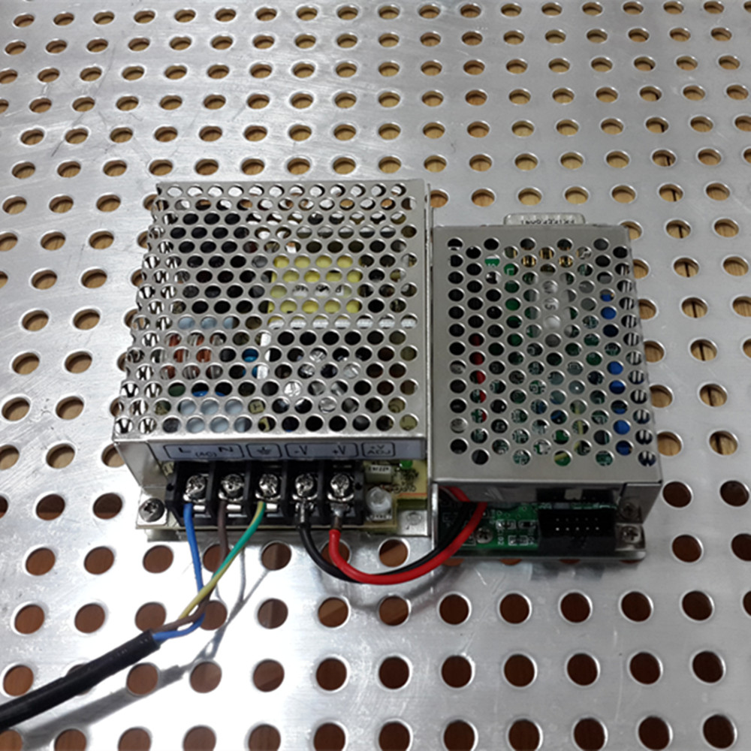
- The power installation instructions
Driver interface
- Connect the plug of the laser head and power supply socket, fixed interface screw.
- According to the standard voltage of laser power supply open it.
- Operating instructions
- Please confirm when you start the laser power switch control terminal not loose.
- Connect the plug of the laser head and power supply socket, fixed interface screw.
- Make sure the power supply voltage to the voltage required for laser, and then plug in the power supply plug, laser began to work.
- Close the laser: to cut off the power supply voltage (pull out the power plug).
The power cord interface
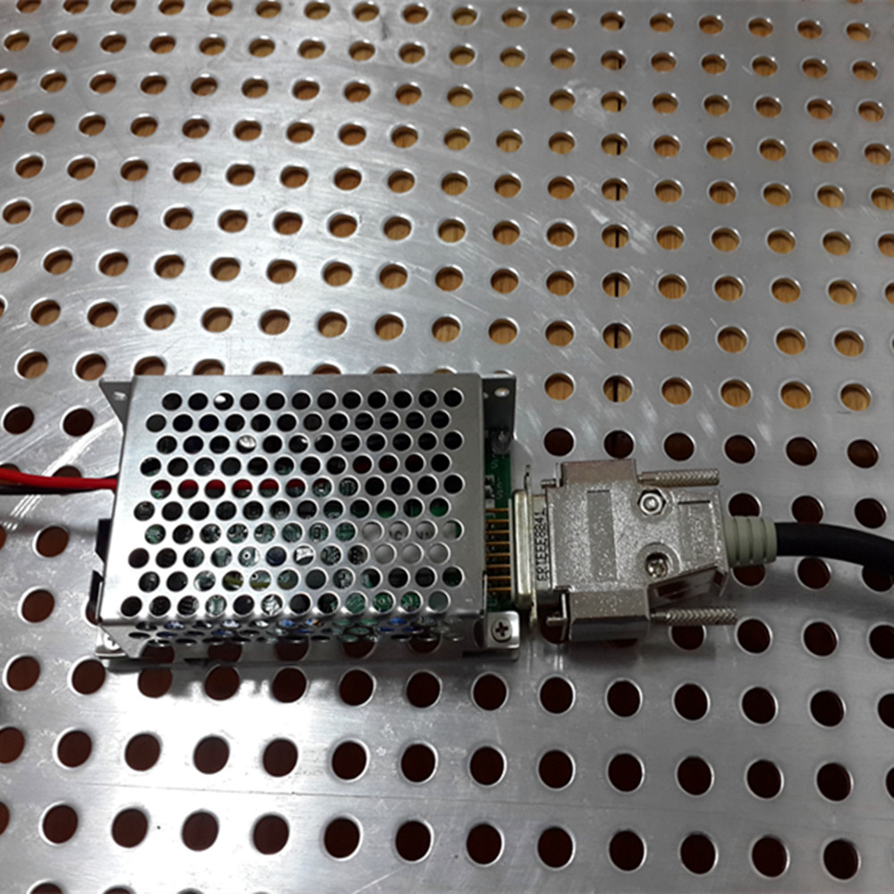
三．Use the environment
- The temperature:10—35℃ （Environment temperature）
15needle socket
25±3℃ (Bottom floor temperature/advice)
Attention: To extend the life of the laser, it is suggested that not more than the temperature range of use, if beyond its limit temperature of the entire system will be shut down. If not in accordance with this specification will cause fatal damage to the laser operation, all laser with electrostatic discharge protection.

- In order to guarantee the stability of the power, all the machines should ensure that don't use vibration environment
- The humidity: 80 + 10%
If the humidity is beyond the scope, the laser will be indirect damage (crystal deliquescence, short circuit, etc.)
- The rated voltage (see test report)
If according to the standard operation will not result in permanent damage to the laser.
If the possibility of voltage instability has the following several kinds of damage
A. integrated circuit is damaged, crystal refrigeration is beyond the scope of value (crystal refrigeration damaged), the output power down, fan doesn't work.
B. instantaneous peak current in the power supply is not stable LD damaged.
C. electrostatic will lead to unstable voltage/potentiometer resistance/capacitance / / PC/IC/temperature control circuit board is damaged.
四． The warranty and maintenance
1. This product from the date of sold, warranty period is one year.
2. Any of the following circumstances. The company shall not be liable for any warranty.
1. Misuse, improper operation, improper storage or without permission operation, and some dealers to add processing operations such as;
2. Removed, damage or change the original print label or tag;
3. Not fault caused by material or process defects directly;
3. This product should be in a clean, dry, dust-free and electrostatic used under the bad border.
4. To use when dealing with optical clean gloves, latex gloves and other insulation equipment.
5. If there is any question, please contact us.
6. Before reading instruction in order to avoid dangerous, please do not open the laser removal ，must wear goggles when laser cover and have special nursing measures.
7. Please use according to the instruction manual.
五． Attention
1. Please put the laser on reliability heat dissipation good tablet;
2. The required temperature slow change within 10 ℃, 35 ℃, otherwise the laser will not be able to better work. We strongly recommend that the laser on the heat dissipation good platform, otherwise will lead to laser fatal damage.
0.05 m, 0.1 m (3) to determine the laser system without any obstacle;
4. If the laser system needs to be installed inside the other equipment, please ensure that the ventilation is good, may, when necessary, extra fan for heat dissipation.

